**ABOUT US:**

**OSIMLAI ADVENTURES** is a native-run company that is based in Arusha: the gateway to Tanzania’s glorious National Parks. We specialize in authentic, sustainable tours throughout Tanzania and offer a variety of packages that will take you off the beaten track.

Our adventure, nature, culture and beach holiday tours are designed to share the unique cultural and environmental marvels of Tanzania whilst positively impacting our local communities and conserving our natural landscapes. We believe that responsible tourism enriches the lives of travelers and allows local communities to prosper whilst also safeguarding their rich ancestral and natural heritage.

We offer customized tours, run by a team of charming tour experts who are all of Tanzanian origin.  We will ensure that you have an immersive, real and breathtaking Tanzanian experience.

Why book with us?

**MONICA:**

Monica is the Founder and CEO of **OSIMLAI ADVENTURES**. She launched this tour company in order to share her passion and enthusiasm for her country. The authentic Maasai village of Engaruka, which is located north of Tanzania on the floor of the Great East African Rift Valley, is where she was born and raised.  In the depth of this Maasai land, female child formal education is not prioritized in the culture and teachings of the people. However, Monica’s parents understood the importance of higher education and pushed her to pursue education to higher levels.  Monica’s dream is to give back to her community pass on her parents’ desire to open up doors to further female education in the Maasai community. With her experience, expertise and passion for the tourism industry, Monica is devoted to providing a unique, tantalizing experience to her clients. The profits generated from bookings with TM are reinvested into Monica’s community to support her mission in mobilizing and educating under-privileged young girls.

*25% of all booking profits and 100% of all donations are directly invested in our Masai community*

**OUR SUCCESS STORY:**

**Meet Lomayana Lemaina.**

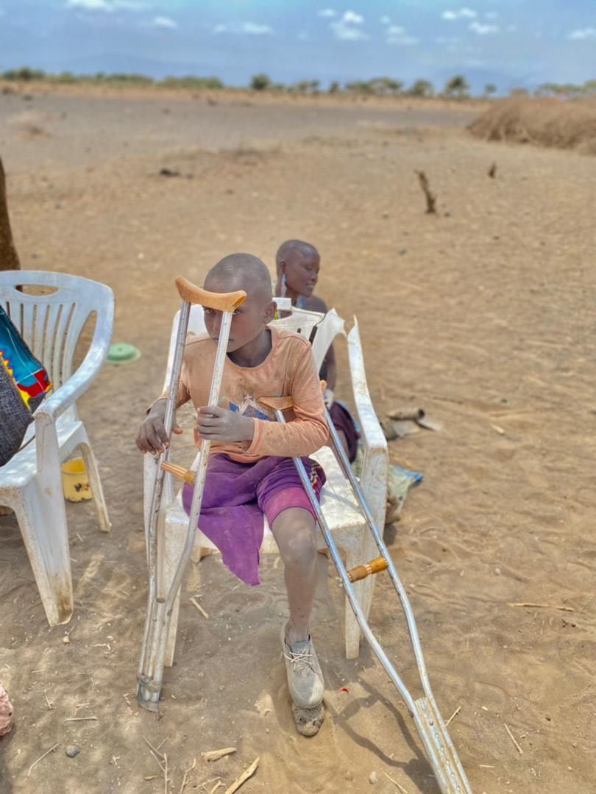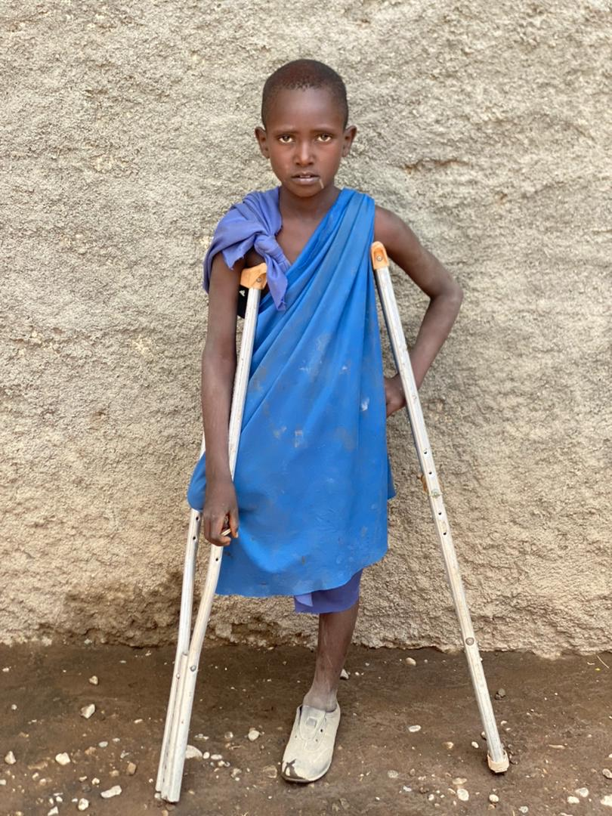

**Lomayana Lemaina** is a 10 years boy from Engaruka. His father has two wives and lomayana is the 5th child from his mother who has 8 children. He was bitten by a snake and failed to get proper treatment hence to his leg being cut. Lomayana goes to a local government school at Engaruka village but does not attend school every day because the school is 4km away from his home and due to his condition, he cannot walk a long distance. **OSIMLAI ADVENTURES** has sponsored Lomayana to start his primary education in a boarding school which will be easier for him because he will be staying at school and be taken care of. He was so thankful that now he is going to get good food and a nice place to sleep, things which he did not have before.